Coast Salish Drum

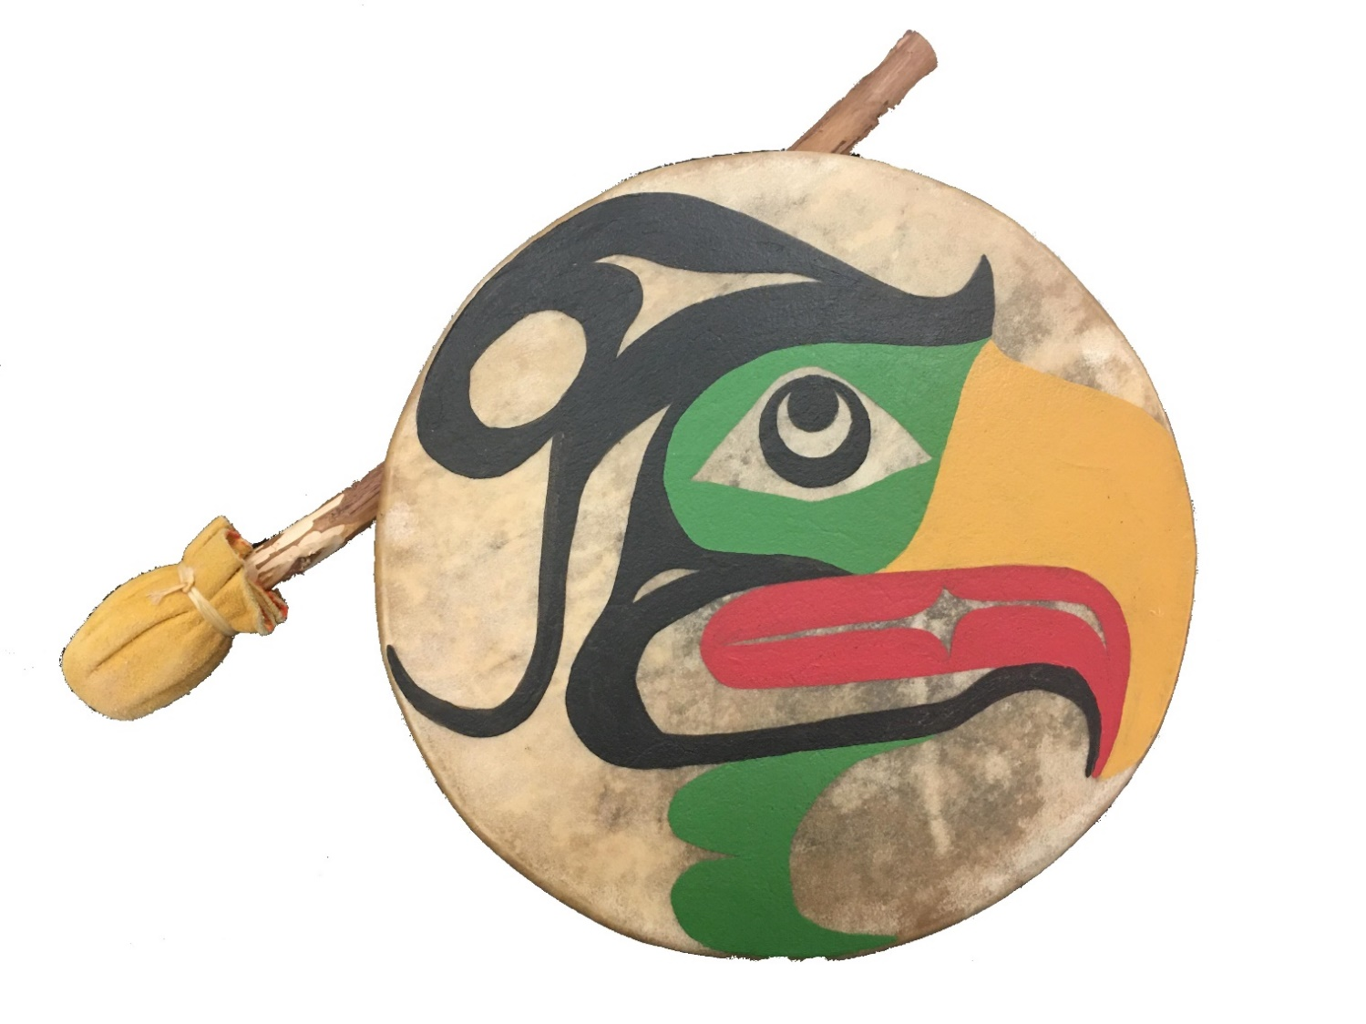

Name:________________________________
Date:_____________Grade:_____Block:_____
Subject:_______________________________
Dimensions of the Bentwood Box:

Part Name | Wood Type | Finish Size  (Imperial / Metric) |  |  | Qty
 |  | Thickness | Width | Length
Sides | Red Cedar | 5/8”  16 mm | 2 ½”  64 mm | 2”  51 mm | 12

Build Instructions:
Cutting Out the Drum Shell
- Rough cut one provided board of Red Cedar (1x6 board) to 14 inches / 356 mm in length.
- Joint one face and one edge of the piece so it is flat (mark jointed sides)
- Plane the piece to 5/8” / 16mm in thickness
- Set the table saw angle to 15 degrees
- Rip (table saw) piece into two 2 ½” / 64mm wide strips
- Rotate pieces 180 degrees and run through the table saw again so your two strip have an end profile like shown below:
|------ 2 ½” / 64mm -----|

- Once both boards have the V-shape, as shown above, set the table saw blade back to 90 degrees
- Using safe crosscutting practices with a stop block, cut the two strips into 2” / 51mm lengths
- You should now have the 12 pieces you will need to make the drum shell.
Gluing Up the Drum Shell
- Dry fit the 12 cut pieces and make sure they will make a complete circle when the 15-degree angle sides are all put together. If they don’t make a circle with tight corners, talk to your instructor about adjusting them.
- Once all corners and angles fit correctly, lay out two pieces of masking tape side by side with the sticky side up on a flat surface. Place the outside side each piece onto the sticky side of the tape. Line all pieces in a row. Make sure all corners are tight with no gaps.
- Put a moderate amount of glue in all the “valleys” created by the angle sides being put together. Roll the drum with tape into the shape of a drum shell and make sure the tape is tight. Let dry overnight.

Trimming the Drum Shell
- Using a circle cutting jig on the band saw, cut the drum shell into a perfect circle.
- Sand the edges until flat. If edges are out by more than 1mm it may require instructor help.
- Sand the rough edges of the sides to prevent damage to the hide that will be stretched over the drum shell

Apply the hide

- Cut a 14” diameter circle from the hide.
- 32 holes (16 sets of 2 and evenly spaced) need to be punched through the hide approx. ½” / 13mm from the hides outer edge. The sets should be spaced a approx. ½” to ¾” / 13mm to 19mm apart.
- Using a singular hide strip/lace (21 ft in length) or a paracord rope, lace the drum in a crisscross pattern and lacing up a handle as show in the YouTube video by Jorge Lewis and Phil Ives, How to make a traditional Coast Salish Drum: Jorge Lewis Drum Maker.
- Let drum dry for 1 or 2 days, avoid hitting it until completely dry.

Design Plan: Rough Design Sketches

Often, Indigenous drums are adorned with paintings often depicting animals of cultural important. Draw some ideas for your drum. Use a scrap piece of paper if you run out of room.

Design Plan: Final Designs

Design Plan: Written Paragraph

Using the space provided, write a paragraph explaining the reasoning behind your design. Why did you choose your design? Is your design meant to serve a specific purpose? Use full sentences.
____________________________________________________________________________
____________________________________________________________________________
____________________________________________________________________________
____________________________________________________________________________
____________________________________________________________________________
____________________________________________________________________________
____________________________________________________________________________
____________________________________________________________________________
____________________________________________________________________________
____________________________________________________________________________

