Bentwood Box

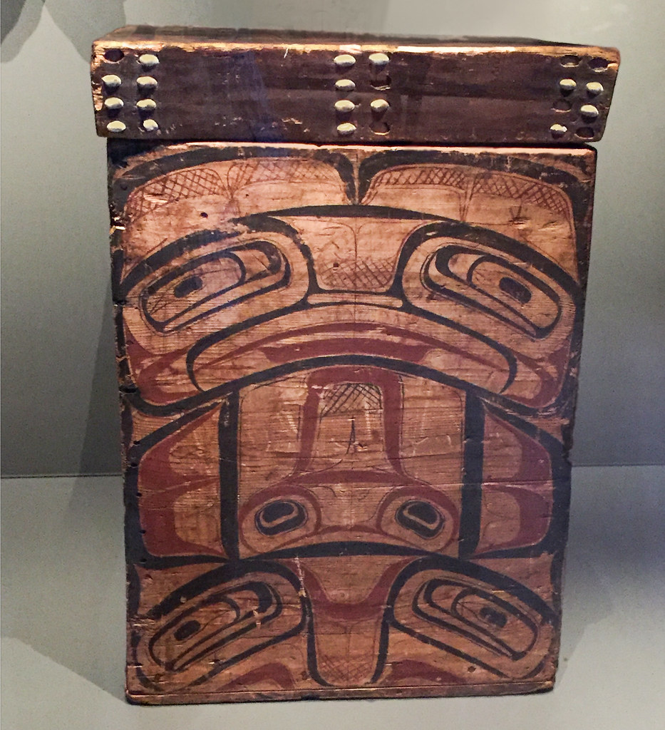
"Bentwood Box and Lid" by A.Davey is licensed under CC BY-NC-ND 2.0

Name:________________________________
Date:_____________Grade:_____Block:_____
Subject:_______________________________
Dimensions of the Bentwood Box:

Part Name | Wood Type | Finish Size  (Imperial / Metric) |  |  | Qty
 |  | Thickness | Width | Length
Sides | Red Cedar | ½”  12mm | 4 ½”  114 mm | 18”  457mm | 1 per box
Bottom | Red Cedar | ½”  12mm | 5”  127mm | 5”  127mm | 1 per box
Top | Red Cedar | 1 ¼”  32mm | 5 ¼”  133mm | 5 ¼”  133mm | 1 per box

Build Instructions:

The Box Body

- Cut your Red Cedar Board into three pieces each 20 inches / 508 mm.
- Joint one face and one edge of three pieces so they are flat (mark them)
- Plane the 3 pieces to 11mm in thickness
- Lay one piece to the side. It will be the boxes bottom later.
- Rip (table saw) 2 pieces to 4 ½” / 114mm
- Crosscut (table saw) 45-degree angles on both ends of 2 boards to a length of 18” / 457mm
- Sand the smaller face side (80 – 180 grit). This will save you sanding the inside of the box later which can be difficult.
- Mark from one end of your boards the following points:
  - 4 ½” / 114mm
  - 9” / 229mm
  - 13 ½” / 343mm
- Re-measure the same distances from the opposite end. Your marks should be in the same spots already marked.
- Use a square to properly mark your measurements
- Using the router jig, cut V-shaped grooves across the grain using the lines you have drawn as a guide. Ask your instructor for help if you require it.
- Once both boards have three V-grooves each, ready the steam box.
- When the box is hot and steaming place your two boards in for 45 minutes.
- Remove boards and slowly fold into a cube shape. If edges start to break put the piece back in the steam box for another 15 minutes and inform your instructor.
- Use elastic bands to hold cube shape.
- Place in vice in diamond shape and tighten vice until box is square (use a square).
- Let box sit overnight

The Bottom

- On the table saw, rip the 20” / 508mm piece you set aside earlier down to 5” / 127mm.
- Using the crosscut sled on the table saw, crosscut piece on one end taking off minimal material. This is to create a true 90-degree end.
- Measure and mark 5” / 127mm and crosscut on the table saw. Repeat. You should have two 5” x 5” / 127mm x 127mm pieces. These are your two bottom pieces.

Binding the Box Bodies Open Corner

- Remove elastic bands. Your cube should hold its shape. If it does not, reattach the elastic bands.
- With a pencil mark a parallel line to the open corner side at ¼” / 6mm from the corner (both sides).
- Down one side mark a perpendicular line at:
  - 1 ½” / 38mm
  - 3” / 76mm
- Down the other side mark perpendicular lines at:
  - ¾” / 19mm
  - 2 ¼” / 57mm
  - 3 ¾” / 98mm
  - Tape up the open corner insuring it is tightly closed and will not easily move.
- Using an Awl, make an indent in the cross points you just marked
- Obtain small dowels from your instructor
- Using the drill press or hand drill, drill holes approximately 1” deep where marked. Use a drill bit appropriate to the dowel diameter.
- Dry fit the dowel to make sure it fits correctly.
- Using a hand saw, cut the dowels into lengths approximately 1 ½” / 38mm long
- Glue up dowel pieces and push them as deep as they will go into the holes and let dry over night. Ensure corner is tight and will not move. Clamp if necessary.

Attaching the Bottom to the Body

- Place the body on top of the bottom piece cut earlier and center the body to the bottom.
- Once centered, using a pencil, trace the outside and inside of the box body to the bottom. This will help you mark where holes will be drilled.
- When marked remove the box body.
- Centered between the lines just drawn, mark 1-1/8” / 29mm from the edge of the bottom piece. You should have 2 marks for holes per side of the box for a total of 8 holes in total.
- Confirm your layout using an awl to make a depression in the wood.
- Place body on the bottom and line it back up to your pencil marks.
- Carefully flip it over. Ensure it does not move on you.
- Drill holes to the same diameter and depth previously used for the corners using the drill press or a hand drill.
- Glue dowel and push tightly into holes.
- Squeeze box in a vise and leave overnight to ensure a tight fit. You may need to place a small block of wood between the bottom (where the dowels stick out) and the vice.

The Lid

- Crosscut wood for lid to a length of 12” / 305mm
- Joint one face and one edge
- Plane to a thickness of 1 ¼” / 32mm
- Rip board to 5 ¼” / 133mm
- Crosscut a finished end (creating a 90-degree corner) using the miter gauge/sled on the table saw.
- Crosscut 5 ¼” x 5 ¼” (133mm x 133mm) squares using the miter gauge/sled on the table saw.
- Measure the inside opening of your box. It should be around 3-11/16” / 94mm. If it is very different talk to your instructor.
- Using the router table, cut out a 1mm deep groove on all four sides of the bottom side of the lid. You want the raised 1mm square to fit tightly into the box opening.
- Set the table saw blade to 10 degrees and cut a bevel on all four sides of the lid with the top side remaining 5 ¼” / 133mm.
- Test lid to fit and adjust if needed.

The Finish

- Sand box (with the grain) from 80 – 180 grit
- Consider a painted or carved design for the 4 sides.
- Apply a clear stain or protective finish

Design Plan: Rough Design Sketches

Draw some ideas and try new things. Use a scrap piece of paper if you run out of room.

Design Plan: Final Designs

Design Plan: Written Paragraph

Using the space provided, write a paragraph explaining the reasoning behind your design. Why did you choose your design? Is your design meant to serve a specific purpose? Use full sentences.
____________________________________________________________________________
____________________________________________________________________________
____________________________________________________________________________
____________________________________________________________________________
____________________________________________________________________________
____________________________________________________________________________
____________________________________________________________________________
____________________________________________________________________________
____________________________________________________________________________
____________________________________________________________________________

